The orginal paper of SKAT is Rare-Variant Association Testing

for Sequencing Data with the Sequence Kernel Association Test

%% KMTest_Linear_Linear

Z=Z.*weights;

Q_temp = res' * Z;

Q = Q_temp * Q_temp'/s2/2;

This part is in

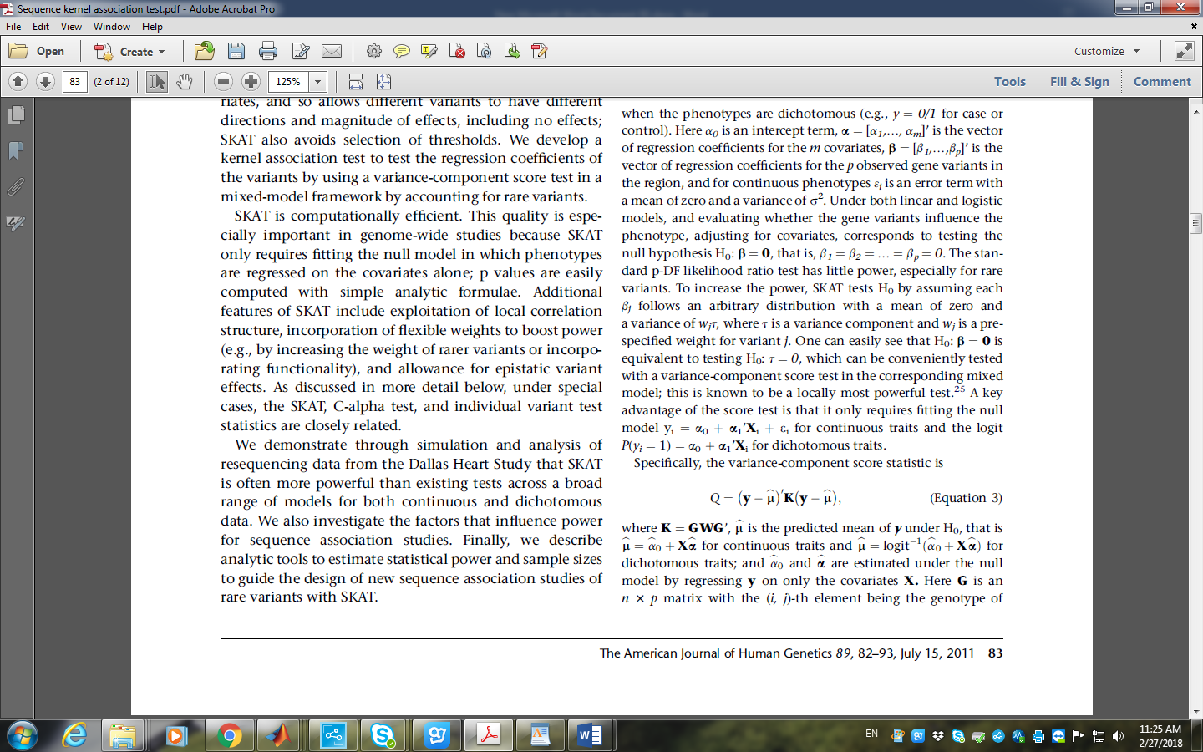

%%

W_1 = Z' * Z - (Z' * X1) * inv(X1' * X1) * (X1' * Z);%%%???

This part is not directly mentioned in the original paper, I think it is

related to

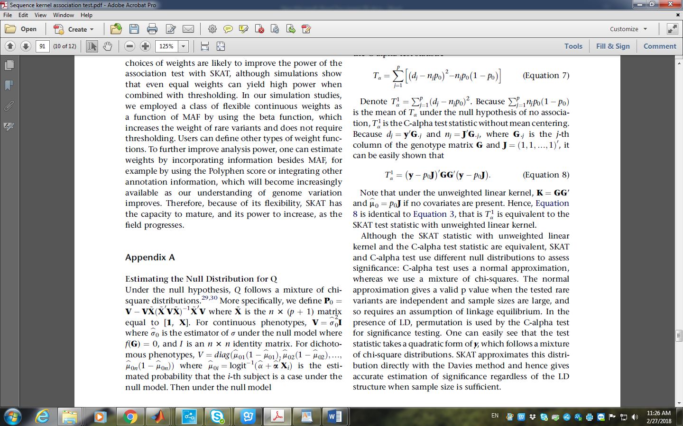

the equation look similar

%% Get_Davies_PVal

K = W_1/2;

This part is just mentioned in

